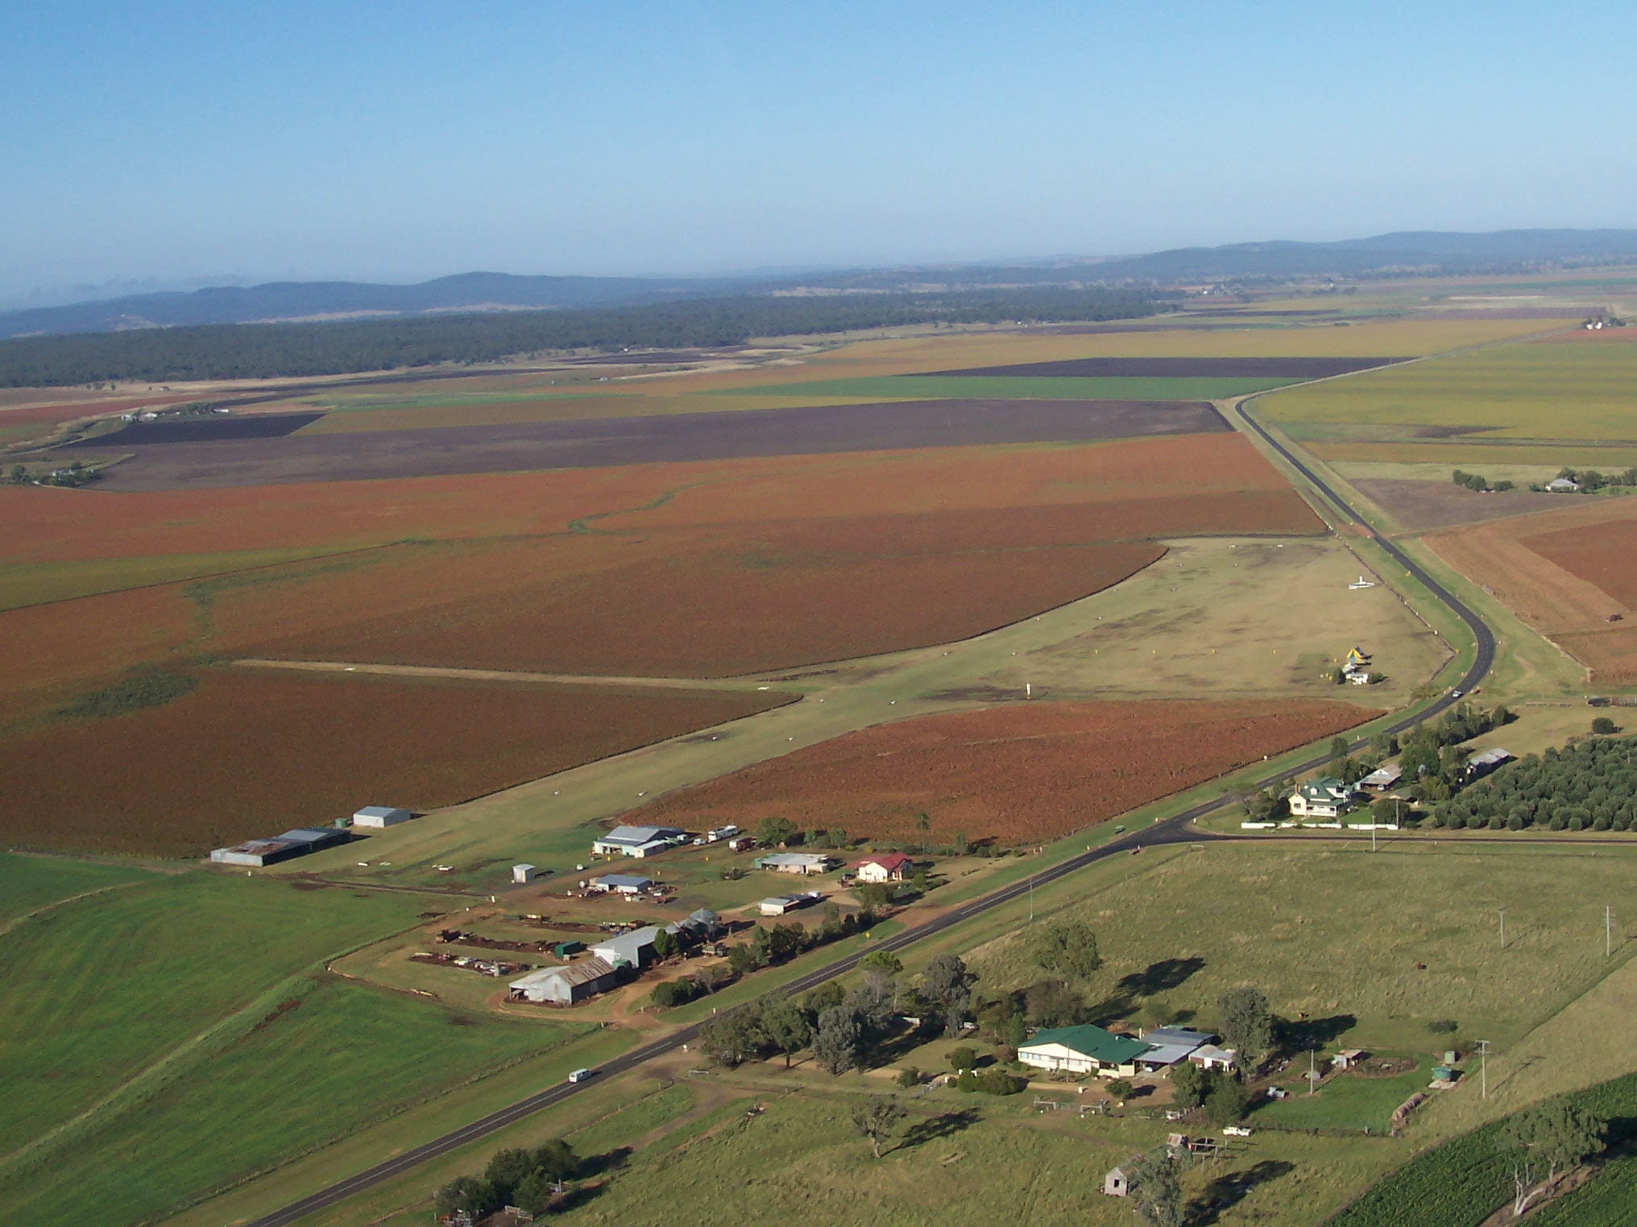
This year, 2025, join us for the
Darling Downs Sport Aircraft Assn Inc
“Annual Clifton Fly-In”
Latitude S 27 55.66 Longitude E 151 50.85 Freq 126.7 multicom
Elevation 1500, Runway 06/24, 800meters. Right hand circuits runway 06
(aircraft join via midfield crosswind and conduct all circuits on the south side of the runway)
6 km west of Clifton, adjacent the Clifton-Leyburn Road, 24 nautical miles south of Toowoomba
Sunday 15th June 2025
Free Breakfast from 8 am - 10am
* Please pre-register on Lone Eagle Flying School website
at www.loneeagleflyingschool.org.au
* Ring to confirm airfield condition prior
to coming due to the unseasonable
weather we can have
* Sunday Morning Free Breakfast from
8am to 10am (donations appreciated)
* Coffee van on site (Charge)
* Avgas / Mogas by arrangement
Cash or direct deposit only

NO PETS PLEASE

Open to the Public, no admission fees
Fly or drive in, bring family/friends
for an enjoyable morning
FREE TEA, COFFEE IN HANGAR
For Clifton Airfield details: refer to ERSA
Fly-In Information phone Trevor on 0429 378 370
View On field cameras & weather station on the website

Website: www.loneeagleflyingschool.org.au
Email: admin@loneeagleflyingschool.org.au
Find us on Facebook at : https://www.facebook.com/LoneEagleFlyingSchool/
Organised by: Darling Downs Sport Aircraft Assn. Inc., 549 Clifton-Leyburn Rd, Clifton. Qld. 4361 Compiled: 28/05/2025

